BLOSSOM VALLEY POPPY Z BRITE
6-GENERATION PEDIGREE
AKC Registration #: | RN189353/01 | Breed/Variety: | Parson Russell Terrier
Birth Date: | 05/25/2009 | Sex: | Female
Colors/Markings: | White/Tri | Breeder/Owner: | Annette Gilliam

Ch Blossom Valley Ghost Buster II  RN119703/05  08/24/2006  BAER JT-BR332/1M-PI  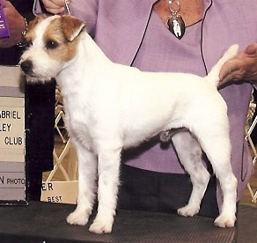 | CH Ultra Quest Casper The Ghost  AKC DNA #V201226, CERF34  RM341931/06 04-02  4/16/2001  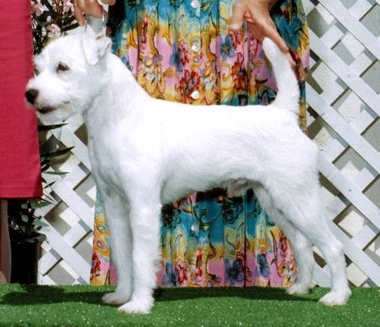 | CH Barsetta Ultra JE  RM243454/01 10-98 (United Kingdom)  Wht/Tan, Smooth, 12.5”  AKC DNA #V125594  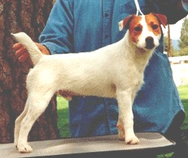 | Barsetta Edward  Tri, Broken, 13”  KCR W2610103W02 | Digmoor Taffy From Barsetta  KCR Q0095891Q03 | Foxwarren Tegwyn At Digmoor KCR Q0095893Q03
Digmoor Mitzi
KCR R0095122R01
 |  |  |  | Barsetta Smitten  KCR V1250904V01 | Hoelio Turk  KCR TZ729201T02
Barsetta Jackie May
KCR T3750804T03
 |  |  | Barsetta Quaint  Wht/Tan, Smooth, 13”  KCR U4665204U04 | Digmoor Taffy From Barsetta  KCR Q0095891Q03 | Foxwarren Tegwyn At Digmoor KCR Q0095893Q03
Digmoor Mitzi
KCR R0095122R01
 |  |  |  | Barsetta Gail  Wht/Tan, Smooth  KCR S3709302S03 | Kenterfox Bill  KCR Q0701603Q04
Somerwest Jessie
KCR Q4538602Q04
 |  | CH Spirit Valleys Kizmet  RM299757/02 12-00  Wht/Tan, Broken  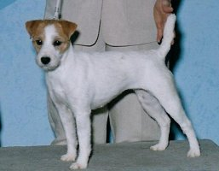 | CH Snow Winds Zipper  RM203320/01 06-99  Tri, Broken, 13”  OFA64G AKC DNA #V118311 | Hoelio Washington  RM200631/01 03-98  Wht/Tan | Kentee Dougal  KCR T0079605T01
Iuydene Ono
KCR R2435201R02
 |  |  |  | Glenholm Calzeat  RM175464/01 01-98  Tri | Hoelio Calum Of Glenholm  JRBA BA191495
Glenholm Chrissie
JRBA BA106295
 |  |  | CH Snow Wind Cosy Morningstar JE  RM207613/06 01-99  Tri | CH Heythrop Trailblazer  RM202764/01 12-97  Tri, Broken, 13.75”  AKC DNA #V34719 | Heythrop Tweed  JRGB PJUNRHH011
Heythrop Trouble
JRGB PJUNRHH009
 |  |  |  | Belmorr Carina Of Snow Wind  Tri RM174469/01 01-98 | Cassacre Boatswain  JRBA BA61595
Glenholm Kunzel
JRBA BA147695
 | CH Ultra Quest Winners Circle  RM350545/01  Tri, Broken, 12”  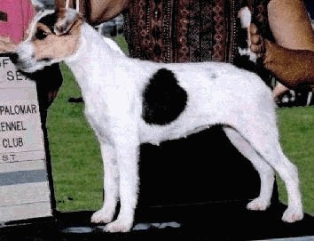 | CH Barsetta Ultra JE  RM243454/01 10-98 (United Kingdom)  Wht/Tan, Smooth, 12.5”  AKC DNA #V125594 | Barsetta Edward  Tri, Broken, 13”  KCR W2610103W02 | Digmoor Taffy From Barsetta KCR Q0095891Q03 | Foxwarren Tegwyn At Digmoor KCR Q0095893Q03
Digmoor Mitzi
KCR R0095122R01
 |  |  |  | Barsetta Smitten  KCR V1250904V01 | Hoelio Turk  KCR TZ729201T02
Barsetta Jackie May
KCR T3750804T03
 |  |  | Barsetta Quaint  Wht/Tan, Smooth, 13”  KCR U4665204U04 | Digmoor Taffy From Barsetta KCR Q0095891Q03 | Foxwarren Tegwyn At Digmoor KCR Q0095893Q03
Digmoor Mitzi
KCR R0095122R01
 |  |  |  | Barsetta Gail  Wht/Tan, Smooth  KCR S3709302S03 | Kenterfox Bill  KCR Q0701603Q04
Somerwest Jessie
KCR Q4538602Q04
 |  | Spring Rain Sienna  Tri - Broken – 12”  RM26037602  12/10/1998  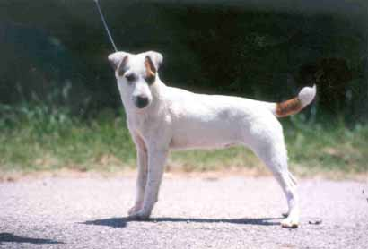 | Crossewind's Trask  B&W  RM18214101  9/4/1993 | Tenor of Crossewind’s | Sayner’s Digger II
 |  |  |  |  | Tuppence
 |  |  |  | Windy Hill Trivet | Rex of Windy Hill
 |  |  |  |  | Trim
 |  |  | Windy Hill Batik  Tri  RM19954202  2/13/1997 | Pengelli Bullet  Tri 5/18/1992  RM17595301 | Jasper (D Jones)
 |  |  |  |  | Pengelli Crisp
 |  |  |  | Larkswood Lizzie  RM17595401  10/18/1991 | Klaus
 |  |  |  |  | Larkswood Pip

CH Whitetail Run SPR Ode to Joy  RN040864/02  12/23/2003  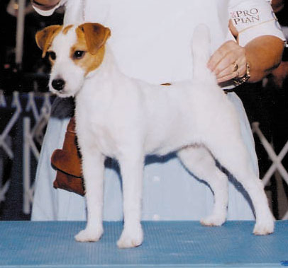 | CH Eastlake Star  RM306248/05 09-02  White Tan Markings  AKC DNA #V249329  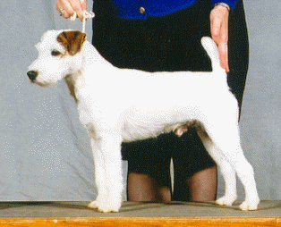 | CH Howlbeck Uno-Who JE  RM283988/01 05-00 (United Kingdom)  White Tri-Colored  AKC DNA #V167433  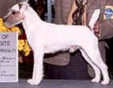 | Howlbeck Pacific Diver  KCR U3341603U03 | Howlbeck Marine Diver  KCR S4711103S04 | Ridley Renegade Of Westbeck  KCR R0582402R01
Ground Hill Midge
KCR Q0096044Q04
 |  |  |  | Howlbeck Pebbles  JRBA BA2070/96 | Ground Hill Kim  JRTC Q0096040Q04
Ground Hill Pip
KCR Q0096041Q04
 |  |  | Howlbeck Tinker Tailer  KCR S3474604S03 | Howlbeck Piper  KCR R2034102R02 | Ground Hill Kim  JRTC Q0096040Q04
Ground Hill Pip
KCR Q0096041Q04
 |  |  |  | Ground Hill Twist  KCR Q0096043Q04 | Ground Hill Kim  JRTC Q0096040Q04
Tinker
JRTC BA1453-95/02
 |  | Eastlake Ava  RM182144/01 10-98  White Tri-Colored  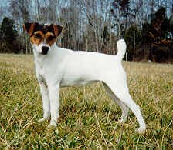 | Windy Hill Whipper Snapper Of Merrill's  JRTC A18389 | Foxwarren Todd Of Windyhill  JRTC E22787 | Dodger Of Foxwarren  461/82
Foxwarren Cleo
JRTC FE151-84
 |  |  |  | Windy Hill Nina  JRTC A8388 | Pathfinder Satan  JRTC E83-86
Windy Hill Bobbin
JRTC A31-87
 |  |  | Killare Kendall  JRTC A16491 | Pleasant Valley Pistol  JRTC A17688 | Pleasant Valley Matt  JRBA BA1254/95
Pleasant Valley Wildfire
JRBA BA1432/95
 |  |  |  | Briarpatch Tuppence  JRTC A16389 | Maven's Tailor  JRTC E129-87
Briarpatch Bramble
JRTC A173-85
 | CH Eastlake Lady Juliet Of Brookeshire  RM292086/04 09-01  White Tri-Colored  AKC DNA #V150517  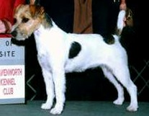 | CH Corn Row Tyler  RM181967/01 02-98  White Tan Markings  OFA68G OFEL68 CERF136 AKC DNA #V61015  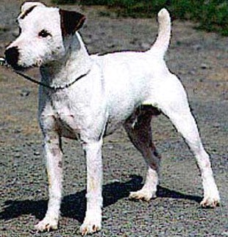 | Windermere Solo  JRBA A20892 | Tenor Of Crosswinds  JRBA E18091 | Digger II  JRBA BA646/95
Tuppence
JRBA BA1020/95
 |  |  |  | Windermere Wasp  JRBA A3990 | (Not Available Online)
 |  |  |  |  | (Not Available Online)
 |  |  | Rooson's Tink  JRBA A29692 | Foxwarren Warlock  JRTC E4090 | (Not Available Online)
 |  |  |  |  | (Not Available Online)
 |  |  |  | Rooson Contessa  JRBA A9-87 | (Not Available Online)
 |  |  |  |  | (Not Available Online)
 |  | Eastlake Slater  RM250726/01 02-00  White Tri-Colored  AKC DNA #V321510  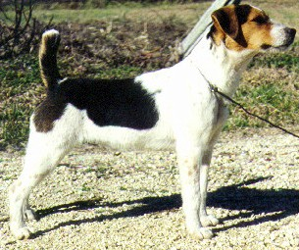 | CH Eastlake Brutus  RM197025/01 10-98  White  AKC DNA #V113536 | Eastlake Brewster  RM182121/02 02-98  White Tri-Colored  AKC DNA #V234646 | Kent  RM189287/01 04-98  White Tri-Colored  AKC DNA #V132545
Eastlake Eden
RM182135/01 12-98
White Tri-Colored
 |  |  |  | Eastlake Lonnie  RM182359/01 12-98  White Tan Markings | Crossewinds Trask  RM182141/01 07-98  White Black Markings  AKC DNA #V108692
Eastlake Dot
JRTC A25789
 |  |  | Merrill's Mountain Scout  RM182127/01 07-98  White Tri-Colored | Digger  JRBA BA86595 | Scrap (Jones)  JRBA BA99495
Dot
JRBA BA2529-95
 |  |  |  | Falling Branch Derby  JRTC A67293 | Windy Hill Whipper Snapper  JRBA BA2006/96
 |  |  |  |  | (Not Available Online)

